We can add the team members in the insight tab

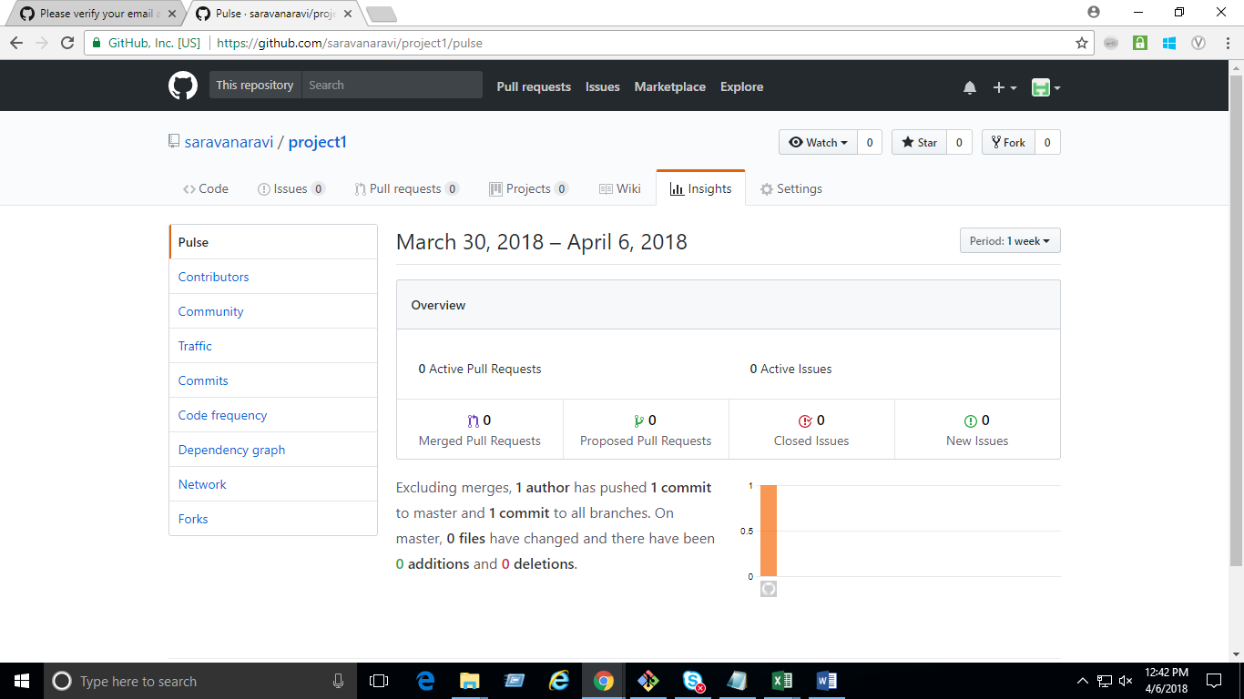

Created another repository in the remote and cloning it to the local

So first I have to come out of the current repostitory so commad should be “cd ..”

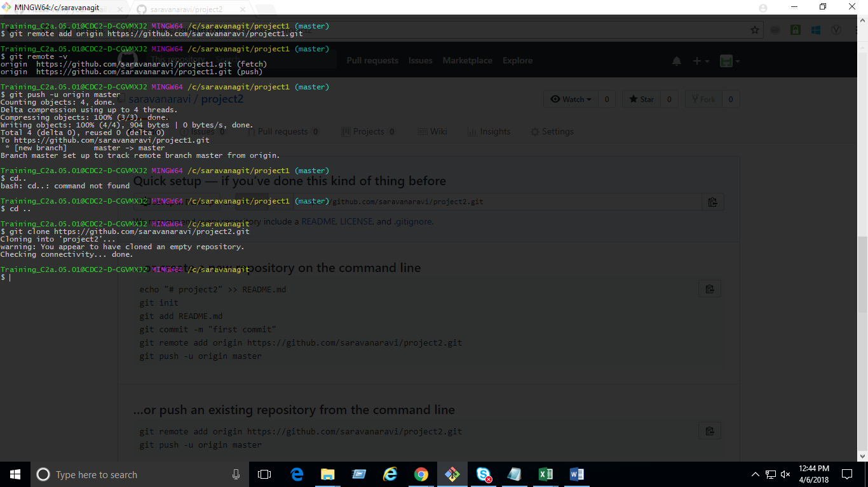

Then we are cloning the remote with the local using the “ git clone paste the link of new repository”

To get into the respective repository “cd project2”

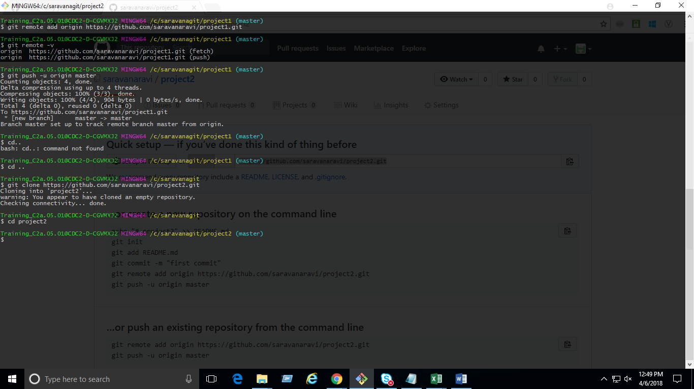

To create and switch to specific branch using command “$ git checkout -b develop”

